Comparison of short-term BP variability in normotensive and hypertensive patients

Ratindra Nath Mondal¹, Md Anowar Hossain², Md. Foyjul Islam³, Md. Zakir Hossain⁴

- Associate Professor of Medicine, Prime Medical College
- CEO, Hypertension and Research Center, Rangpur
- FETP, B (Advance Fellow), Institute of Epidemiology, Disease Control and Research (IEDCR), Dhaka
- Professor and Head of the Department of Medicine, TMSS Medical College

Abstract

Background: Despite controlled blood pressure (BP), some patients develop target organ damage (TOD) such as stroke and ischemic heart disease (IHD). One contributing factor to the development of TOD is increased blood pressure variability (BPV), which is associated with end-organ damage, cardiovascular events, and mortality in hypertension. This study aimed to compare short-term BPV between hypertensive and normotensive patients.
Methodology: A cross-sectional study was conducted at the Hypertension and Research Center, Rangpur, involving 100 hypertensive patients and 100 normotensive participants, all without a history of cardiovascular disease (CVD), diabetes mellitus (DM), or chronic kidney disease (CKD). BP was measured using an automated Omron 7120 device at both the center and home, following a standardized measurement technique. A pretest was conducted to ensure correct home measurement. BP was recorded at specific intervals: 4-6 AM, 6-9 AM, 11 AM, 1 PM, 5 PM, 7-9 PM, and 10-12 PM. At each interval, two readings were taken, and the first reading was discarded. Short-term BP variability was identified if nocturnal systolic BP decreased by less than 10% from the daytime average or increased above daytime levels.
Results: The mean age for hypertensive and normotensive groups was 53.11 ± 9.53 years and 39.37 ± 13.25 years, respectively. For hypertensives, the average office BP was 142.61/85.92 mmHg, while home BP was slightly higher at 143.49/83.91 mmHg. Normotensives had an average office BP of 110/70 mmHg and home BP of 109/75 mmHg. BP variability was observed in 99% of hypertensive individuals, with 64% categorized as non-dippers and 35% as reverse dippers. Among normotensives, 100% exhibited BP variability, with 42.9% showing no dipping and 57.1% reverse dipping.
Conclusion: The study reveals significant short-term BPV in both hypertensive and normotensive subjects, with notable differences in office and home BP readings. Further research using ambulatory blood pressure monitoring (ABPM) and larger sample sizes is recommended to better understand and manage BP variability.

Keywords: Hypertension, dipping, non-dipping, reverse dipping, BPV, Bangladesh

Introduction:

Blood pressure (BP) is a continuous physiological variable that fluctuates in response to various factors, including physical and mental activities, heart rate and rhythm, posture, sleep disturbances, and autonomic, humoral, mechanical, and environmental stimuli. Blood pressure variability (BPV) refers to the short-term fluctuations in BP over time and is influenced by these factors. Several studies have demonstrated that the assessment and quantification of BPV, in addition to traditional BP measurements, can provide significant pathophysiological and prognostic insights, particularly in the context of both normotensive and hypertensive individuals [1]. BPV has been identified as an independent risk factor for various conditions, including dementia, stroke, end-stage renal disease, cardiovascular events, and mortality [2,3].
When relying solely on office BP (OBP) measurements, the identification of at-risk individuals, such as those with white coat hypertension or masked hypertension, may be missed, leading to misdiagnosis, overdiagnosis, or suboptimal treatment strategies. White coat hypertension is characterized by elevated OBP readings with normal ambulatory BP or home BP (HBP), often caused by anxiety or a sympathetic response during clinical visits. Conversely, masked hypertension is characterized by normal OBP readings but elevated ambulatory BP or HBP, which may be overlooked when OBP is the sole measurement used. Therefore, the clinical management of hypertension now strongly recommends the inclusion of HBP or ambulatory BP monitoring (ABPM) to supplement OBP, allowing for a more accurate diagnosis and monitoring of hypertensive patients [4,5].
BPV is defined as the variation in arterial BP over a specified period. The underlying physiology of BPV is complex, involving interactions between hemodynamic, neuronal, humoral, and behavioral factors, such as anxiety, postural changes, and lifestyle, along with environmental factors like atmospheric pressure and climate. Additionally, BPV is influenced by aortic compliance and systemic capacitance and is further complicated by the use of antihypertensive and heart failure treatments [6]. Studies have shown that BPV is a significant and independent risk factor for cardiovascular diseases (CVDs), chronic kidney disease, dementia, stroke, and hypertension-related morbidity and mortality [7]. Although the exact mechanisms are not fully understood, BPV is believed to contribute to target-organ damage through processes such as increased large artery stiffness, vascular remodeling in the microcirculation, activation of the inflammatory cascade, and dysregulation of the sympathetic nervous system and the renin-angiotensin-aldosterone system [8].
In particular, this study focuses on comparing the short-term BPV in normotensive and hypertensive individuals, aiming to elucidate the differences in BP fluctuations and their potential impact on health outcomes in these two groups.

Methodology
Study Design
This was a cross-sectional study conducted at the Hypertension and Research Center, Rangpur, aimed at comparing short-term blood pressure (BP) variability between hypertensive and normotensive individuals.
Study Period
Study Participants
A total of 200 participants were enrolled in the study, with 100 patients diagnosed with hypertension in the hypertensive group and 100 normotensive individuals serving as the comparison group. The normotensive participants had no history of cardiovascular disease (CVD), diabetes mellitus (DM), or chronic kidney disease (CKD). The inclusion criteria for the study required adults aged 18 years or older, with the hypertensive group consisting of individuals with primary hypertension, while the normotensive group included individuals without hypertension. Participants with secondary hypertension were excluded from the study to ensure that only those with primary hypertension or no hypertension were included.
Blood Pressure Measurement Protocol
Blood pressure measurements were performed using an automated Omron 7120 device to ensure accurate and standardized measurement. Participants were trained at the center to ensure correct BP measurement techniques before taking measurements at home.
Pretest Procedure
Prior to commencing home BP measurements, a pretest was conducted at the center to identify and correct any errors in self-measurement techniques.
Measurement Intervals
BP was measured at specified intervals throughout the day:
- 1st Measurement: Between 4 to 6 AM
- 2nd Measurement: Between 6 to 9 AM
- 3rd Measurement: At 11 AM
- 4th Measurement: At 1 PM
- 5th Measurement: At 5 PM
- 6th Measurement: Between 7 to 9 PM
- 7th Measurement: Between 10 to 12 PM
At each interval, two readings were taken, with the first reading discarded to ensure reliability and reduce measurement errors.
Data Collection
Data were collected at the Hypertension and Research Center, Rangpur, following the BP measurement protocol. The Omron 7120 device was used to ensure consistency in measurements. Participants were instructed on the proper BP measurement technique, and their adherence to the measurement schedule was monitored.
Data Recording
BP readings were recorded electronically, noting the date and time of each measurement. The first of the two consecutive readings was discarded to minimize the ‘white coat’ effect and reduce variability due to environmental factors.
Data Management
The collected data were anonymized and coded before analysis. A secure database was maintained with restricted access to ensure the confidentiality and integrity of the data.
Statistical Analysis
Statistical analysis was conducted using SPSS software (version 25.0). Descriptive statistics were used to summarize the demographic characteristics, including means, standard deviations (SD), and frequencies for continuous and categorical variables. Independent sample t-tests were performed to compare the mean systolic and diastolic blood pressure (BP) between hypertensive and normotensive groups at different time intervals (morning, daytime, and nighttime) for both office and home BP measurements. Chi-square tests were used to evaluate the distribution of BP variability patterns (dipping, non-dipping, and reverse dipping) between the two groups. Paired t-tests were applied to assess within-group BP differences across time intervals, and a significance level of p < 0.001 was considered highly significant. For comparisons between active and inactive individuals, box plots and independent sample t-tests were used to examine BP during the day and night. A p-value of <0.05 was considered significant for all analyses.

Result
The study’s socio-demographic analysis reveals notable differences between hypertensive and normotensive groups. The hypertensive group, with an average age of 53.11 years, is older than the normotensive group (38.10 years), and has a higher percentage of females (51%) compared to males (49%). The hypertensive group also has lower education levels, with 17% being illiterate and 54% earning less than 5000 taka monthly, indicating potential links between lower socioeconomic status and higher hypertension prevalence. In contrast, the normotensive group tends to have better education, with 33% completing more than 10 years of schooling and a higher proportion (53%) earning between 10000-14999 taka monthly. Additionally, a larger percentage of normotensive individuals (42%) work in service jobs, while a significant portion of the hypertensive group are housewives (48%). These socio-demographic factors, such as age, income, and education, may contribute to the prevalence and management of hypertension. (Table 1)

Table 1: Socio-demographic characteristics of the study population
 | Hypertensive (100) |  | Normotensive (100)
Variables | Frequency | Percentage (%) | Frequency | Percentage (%)
Mean age | 53.11 ± 9.53 years |  | 38.10±04 years
Sex
Male | 49 | 49.0% | 34 | 34.0%
Female | 51 | 51% | 66 | 66.0%
Residence
Rural | 70 | 70.0% | 73 | 73.0%
Urban | 30 | 30.0% | 27 | 27.0%
Level of education
Illiterate | 17 | 17.0% | 2 | 2.0%
<5 class | 10 | 10.0% | 17 | 17.0%
5-<10 class | 22 | 22.0% | 24 | 24.0%
>10 | 25 | 25.0% | 33 | 33.0%
Graduate and above | 26 | 26.0% | 24 | 24.0%
Occupation

Service | 18 | 18.0% | 42 | 42.0%
Business | 12 | 12% | 7 | 7.0%
Agriculture | 4 | 4.0% | 4 | 4.05
Retired | 3 | 3.0% | 2 | 2.0%
Housewife | 48 | 48.0% | 28 | 28.0%
Others | 15 | 15.0% | 17 | 17.0%
Monthly income

<5000 taka* | 54 | 54.0% | 2 | 2.0%
5000-<10000 taka | 20 | 20.0% | 23 | 23.0%
10000-<15000 taka | 17 | 17.0% | 53 | 53.0%
>15000 taka | 9 | 9.0% | 22 | 22.0%

For hypertensives, the average office BP was 142.61/85.92 mmHg, whereas home BP was slightly higher 143.49/83.91 mmHg, with 49% exhibiting higher home than office BP readings. Normotensives had an average office BP of 110/70 mmHg and home BP of 109/75 mmHg. The average morning, daytime, and nighttime BP readings for hypertensives were 143.36/83 mmHg, 156.69/83.92 mmHg, and 142.72/82.72 mmHg, respectively, compared to 107.63/74.25 mmHg, 109.09/75.77 mmHg, and 110.11/75.61 mmHg for normotensives. (Table 2)

Table 2: Blood pressure distribution (mean BP) of hypertensive and normotensive
participants in different setups and times.
BP Category | Hypertensives (mean BP) | Normotensives (mean BP)
Office BP (mmHg) | 142.61/85.92 | 110/70
Home BP (mmHg) | 143.49/83.91 | 109/75
Morning BP (mmHg) | 143.36/83 | 107.63/74.25
Daytime BP (mmHg) | 156.69/83.92 | 109.09/75.77
Nighttime BP (mmHg) | 142.72/82.72 | 110.11/75.61

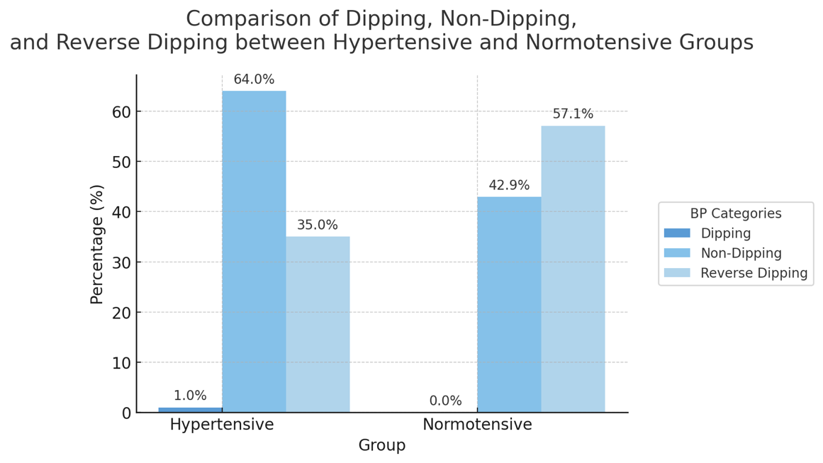
Figure 1: Comparison of dipping, non-dipping, and reverse dipping between Hypertensive
and Normotensive groups

The study observed blood pressure (BP) variability in both hypertensive and normotensive individuals. In hypertensive participants, 99% experienced BP fluctuations throughout the day and night, with 64% classified as non-dippers (BP remained high or stable during the night) and 35% as reverse dippers (BP increased at night). In contrast, 100% of normotensive participants exhibited BP variability, with 42.9% showing no dipping (stable BP throughout the day and night) and 57.1% being reverse dippers (BP increased at night). These findings highlight that BP variability, including non-dipping and reverse dipping, occurs in both groups but is more prevalent in hypertensive individuals, indicating the need for further investigation into the underlying mechanisms of BP variability in both populations. (Figure 1)

The distribution of blood pressure (BP) measurements across different times of the day reveals significant differences between hypertensive and normotensive individuals. Throughout all time intervals, hypertensive individuals consistently exhibit higher systolic blood pressure (SBP) and diastolic blood pressure (DBP) compared to normotensive individuals, with the most substantial differences observed during the daytime. For instance, SBP differences ranged from 33.51 mmHg to 35.7 mmHg, with the highest differences occurring in the afternoon (1-2 PM). Similarly, DBP differences varied between 6.75 mmHg and 15.11 mmHg, with the greatest variation seen at 8-9 PM. These differences were statistically significant (p-value <0.001) across all time points, indicating a persistent and notable elevation of BP in hypertensive individuals. The largest SBP differences occurred in the morning and daytime, while DBP differences were more prominent during the evening, particularly between 8-9 PM. These findings highlight the constant elevation in BP levels in hypertensive individuals across the day, with specific time periods showing more pronounced disparities. (Table 3)

Table 3: Comparison of SBP and DBP between Hypertensive and Normotensive patients
Time | Average of | Hypertensive | Normotensive | Difference | 95% CI
4-6 AM | SBP | 140.24 | 106.73 | 33.51*** | (30.31, 36.71)
 | DBP | 81.96 | 71.74 | 10.22*** | (6.96, 13.48)
6-9AM | SBP | 143.36 | 109.15 | 34.21*** | (30.86, 37.56)
 | DBP | 83.00 | 72.78 | 10.22*** | (6.92, 13.52)
11-12PM | SBP | 142.88 | 107.18 | 35.7*** | (31.78, 39.62)
 | DBP | 82.49 | 73.33 | 9.16*** | (5.97, 12.35)
1-2PM | SBP | 144.98 | 109.76 | 35.22*** | (31.77, 38.67)
 | DBP | 83.86 | 75.85 | 8.01*** | (4.53, 11.49)
5PM | SBP | 143.32 | 108.04 | 35.28*** | (31.88, 38.68)
 | DBP | 82.38 | 74.52 | 7.86*** | (4.67, 11.05)
8-9PM | SBP | 143.02 | 108.61 | 34.41*** | (30.58, 38.24)
 | DBP | 90.55 | 75.44 | 15.11* | (-1.15, 31.37)
10-11PM | SBP | 142.96 | 108.22 | 34.7396*** | (30.97, 38.50)
 | DBP | 81.92 | 75.17 | 6.75*** | (3.43, 10.07)
P-value: *** <0.001; ** <0.01; * <0.05;

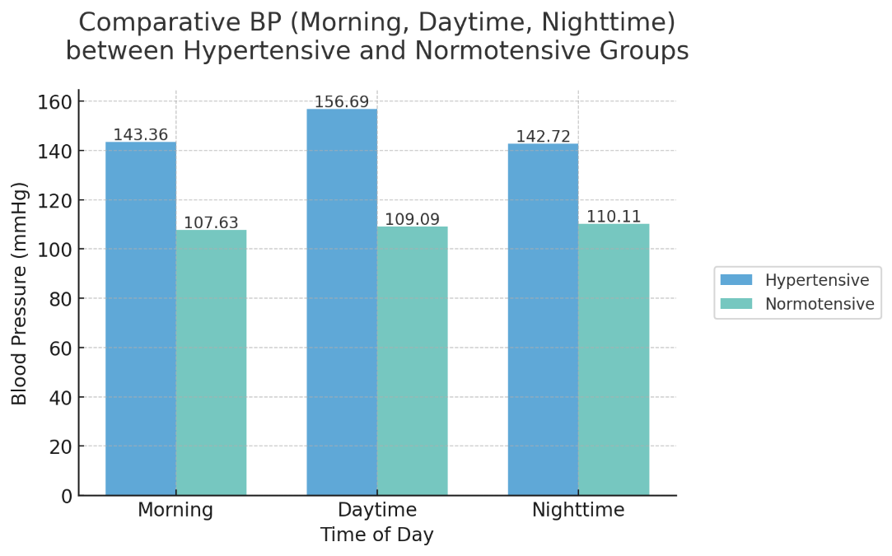
Figure 2: Comparison of BP between Hypertensive and Normotensive participants in
different times.

The study compared blood pressure (BP) between hypertensive and normotensive individuals at different times of the day: morning, daytime, and nighttime. In the morning, hypertensive individuals had significantly higher systolic BP (143.36 mmHg vs. 107.63 mmHg) and diastolic BP (83 mmHg vs. 74.25 mmHg), with a difference of 35.73 mmHg in systolic and 8.75 mmHg in diastolic BP. During the daytime, the difference widened, with hypertensives showing a systolic BP of 156.69 mmHg and a diastolic BP of 83.92 mmHg, compared to normotensives’ 109.09 mmHg and 75.77 mmHg. At nighttime, hypertensives still had higher BP, though the difference was smaller (32.61 mmHg systolic and 7.11 mmHg diastolic). Overall, hypertensives exhibited higher BP throughout the day, with the largest differences observed during the daytime, emphasizing the persistent nature of hypertension. (Figure 2)
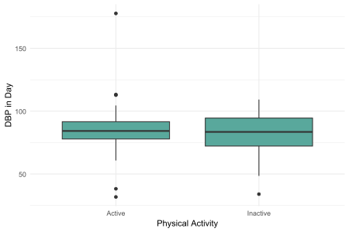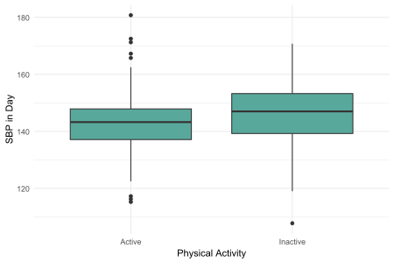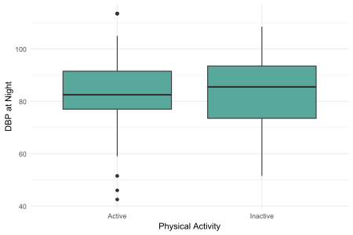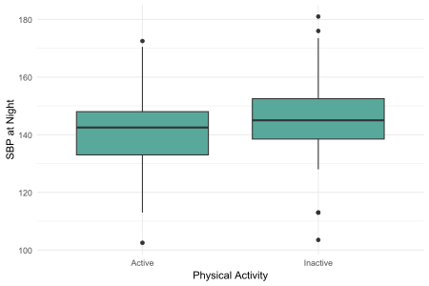
Figure 3: Comparison of blood pressure (both DBP and SBP) during the day and night
between active and inactive individuals.
The boxplots comparing blood pressure (BP) during the day and night between active and inactive individuals reveal distinct trends. During the daytime, active individuals generally have lower and more consistent BP, with narrower ranges for both diastolic (DBP) and systolic blood pressure (SBP), indicating better control. In contrast, inactive individuals show higher BP with more variability, especially with several outliers, suggesting that inactivity contributes to increased BP. At night, both groups exhibit similar median DBP values, though active individuals have slightly more variation in their nighttime BP. Interestingly, the inactive group has slightly lower DBP at night, but the variation is less pronounced than during the day. For SBP at night, active individuals maintain lower median levels, while the inactive group shows higher variability, suggesting more pronounced fluctuations. These results highlight that physical activity is linked to lower and more stable BP both day and night, while inactivity is associated with higher and more erratic BP, especially during the daytime. (Figure 3)
 | Hypertensive (%) | Normotensive (%)
Grading of BMI
Obese | 17% | 20%
Overweight | 41% | 51%
Dietary Modification | 68% | -
Regular Exercise | 34% | -
Antihypertensive Drugs | 94% | -
Added Salt | 28% | 24%
Physical Activity (Inactive) | 29% | 33%
Sedentary Workers | 77% | 62%
Office BP control | 31% | 51.6%
Home BP control | 18% | 29%

In this study, among the hypertensive patients 17% were obese & 41% were overweight. 68% hypertensive patients maintained dietary modification, 34% used to do regular exercise and 94% used to take the antihypertensive drugs regularly. Among the normotensive 24% used to take added salt, 33% were physically inactive, 62% were sedentary workers, 20% were obese and 51% were overweight. Office BP control was achieved in 31% of hypertensive patients, while home BP control was observed in 18%; 51.6% of those with controlled office BP also had controlled home BP, whereas only 29% of patients with uncontrolled office BP showed controlled home BP.
Discussion
This study explored short-term blood pressure (BP) variability in hypertensive and normotensive individuals, comparing their BP patterns across various times of the day. The results reveal significant differences in BP variability between these two groups, with hypertensive patients showing more pronounced fluctuations and abnormal BP patterns. These findings are in line with the body of literature on BP variability and its implications for cardiovascular health.
The hypertensive patients in this study exhibited a higher degree of BP variability compared to their normotensive counterparts. A notable proportion of hypertensive patients were classified as non-dippers (64%) or reverse dippers (35%), indicating that their BP did not follow the typical circadian pattern of dipping at night. These findings align with earlier studies by Mancia et al. (1983) and Pickering (1998), which demonstrated that BP variability, including non-dipping and reverse dipping, is more prevalent in hypertensive individuals [9,10]. Such abnormal BP patterns are associated with a higher risk of cardiovascular events and organ damage [9]. Similarly, studies have shown that hypertensive patients often experience higher variability in BP, which may contribute to long-term health risks such as stroke and heart disease [11].
In contrast, although the normotensive group exhibited BP variability, the patterns were less extreme. A substantial proportion of normotensive individuals (57.1%) were reverse dippers, which has been recognized in some studies as a phenomenon that can occur even in individuals without hypertension [12]. However, normotensives showed more stable BP during the night compared to hypertensive individuals, highlighting the less pronounced risk profile of this group.
The study also revealed significant circadian variation in BP across different times of day. Hypertensive patients consistently had higher systolic BP (SBP) and diastolic BP (DBP) than normotensive individuals, especially during the daytime, with the largest differences observed in the afternoon. This supports earlier research indicating that hypertensive individuals exhibit consistently elevated BP throughout the day, particularly during daytime hours [13]. The lack of a nocturnal BP dip in hypertensive individuals is a key feature distinguishing them from normotensive individuals, who typically exhibit a reduction in BP at night [10,14]. The persistence of high BP during sleep in hypertensive patients is a known risk factor for cardiovascular disease [12].
The differences in BP between the two groups were particularly pronounced in the afternoon and evening hours, suggesting that time-of-day effects are significant in the control of BP. These findings are consistent with previous studies showing that BP variability throughout the day is influenced by circadian rhythms, stress, and activity levels [9,14]. The elevated BP levels observed in hypertensive individuals during the daytime could be attributed to a variety of factors, including increased physical activity, stress, and lifestyle behaviors.
The role of physical activity in BP control is another important finding in this study. Active individuals showed lower and more stable BP during the day, consistent with previous studies that suggest physical activity plays a significant role in controlling BP variability [15]. Active individuals had less variation in both SBP and DBP, indicating that regular exercise helps mitigate BP fluctuations and contributes to overall BP stability. This finding corroborates the work of Steptoe et al. (1995) and Kawano et al. (1996), who found that physical activity is an important factor in the regulation of BP and can reduce the risk of hypertension [16,17]. In contrast, inactive individuals showed higher and more erratic BP patterns, particularly during the daytime, which may be a result of poor lifestyle choices, including lack of exercise and physical inactivity [17].
Lifestyle factors, including smoking, alcohol consumption, and dietary habits, also influence BP variability. Verdecchia et al. (1995) and other studies have shown that factors such as smoking, salt intake, and alcohol consumption can exacerbate BP variability, particularly in individuals with hypertension [18]. In this study, we found that hypertensive patients who adhered to a healthy diet and took antihypertensive medications regularly had more controlled BP, although home BP control was still achieved in only 18% of patients. This highlights the importance of comprehensive lifestyle modifications, including regular exercise and proper medication adherence, in managing BP variability [19].
Moreover, recent studies, such as those by Li et al. (2017) and Wang et al. (2021), have indicated that BP variability is associated with target organ damage, particularly in elderly patients, and may have implications for understanding the cardiovascular risks in hypertensive individuals [20,21]. The connection between BP variability and organ damage underscores the need for monitoring BP patterns over time, emphasizing the importance of individualized care and early intervention to prevent long-term health complications.

Limitations
BPV was assessed by an automated device instead of ABPM. The sample size, although adequate, may not fully represent the broader population, and future studies with larger, more diverse samples would help to confirm the generalizability of these findings.

Conclusion
In conclusion, this study reinforces the significance of BP variability as a key indicator of cardiovascular health. Hypertensive individuals exhibited more pronounced BP fluctuations, including non-dipping and reverse dipping patterns, compared to normotensive individuals. These abnormal BP patterns are associated with an increased risk of cardiovascular events and underline the importance of monitoring BP over 24 hours. The study also emphasizes the beneficial effects of physical activity in controlling BP variability and suggests that a combination of lifestyle modifications and pharmacological management is crucial for maintaining BP within healthy ranges.

Author’s contribution: conceptualized, designed the study, and contributed to data acquisition, analysis, and interpretation. drafted the manuscript, while RNM and MA critically revised it. RNM approved the final version of the manuscript.
Acknowledgment: The authors of this study are grateful to Professor Dr. Md. Mujibur Rahman, staff of Hypertension and Research Centre, Rangpur.
Conflict of interest: There was no conflict of interest
Ethical approval:
Data availability: The datasets used and/or analyzed during the current study are available from the corresponding author upon reasonable request.

References
- Höcht C. Blood pressure variability: prognostic value and therapeutic implications. Int Sch Res Notices. 2013; 2013:1–16.
- Parati G, Ochoa JE, Lombardi C, Bilo G. Assessment and management of blood‐pressure variability. Nat Rev Cardiol. 2013; 10:143–155.
- Parati G, Ochoa JE, Salvi P, Lombardi C, Bilo G. Prognostic value of blood pressure variability and average blood pressure levels in patients with hypertension and diabetes. Diabetes Care. 2013; 36:S312–S324.
- Pickering TG, Hall JE, Appel LJ, Falkner BE, Graves J, Hill MN, Jones DW, Kurtz T, Sheps SG, Roccella EJ. Recommendations for blood pressure measurement in humans and experimental animals: part 1: blood pressure measurement in humans: a statement for professionals from the Subcommittee of Professional and Public Education of the American Heart Association Council on High Blood Pressure Research. Hypertension. 2005; 45:142–161.
- Cifu AS, Davis AM. Prevention, detection, evaluation, and management of high blood pressure in adults. JAMA. 2017; 318:2132–2134.
- Liu Y, Luo X, Jia H, Yu B. The effect of blood pressure variability on coronary atherosclerosis plaques. Front Cardiovasc Med. 2022; 9:803810.
- Li C, Liu R, Wang J, Yang J. Relationship between blood pressure variability and target organ damage in elderly patients. Eur Rev Med Pharmacol Sci. 2017; 21:5451–545.
- Wang H, Sun X, JL VC, Kon ND, Ferrario CM, Groban L. Estrogen receptors are linked to angiotensin‐converting enzyme 2 (ACE2), ADAM metallopeptidase domain 17 (ADAM‐17), and transmembrane protease serine 2 (TMPRSS2) expression in the human atrium: insights into COVID‐19. Hypertens Res. 2021; 44:882–884.
- Mancia G, Ferrari A, Gregorini L, Parati G, Pomidossi G, Bertinieri G, Grassi G, di Rienzo M, Pedotti A, Zanchetti A . Blood pressure and heart rate variabilities in normotensive and hypertensive human being. Circ Res 1983; 53: 96–104.
- Pickering TG . Variability of blood pressure. Blood Press Monit 1998; 3: 141–145.
- Franklin SS, Gustin W, Wong ND, et al. Hemodynamic Patterns of Age-Related Changes in Blood Pressure. Circulation. 1997;96(1):308-315.
- Ohkuboa T, Hozawaa T, Yamaguchi J, Kikuya M, Ohmari K, Michimata M, et al. Prognostic significance of the nocturnal decline in blood pressure in individuals with and without high 24-h blood pressure: the Ohasama study. J Hypertens. (2002) 20:2183–9.
- Millar-Craig MW, Bishop CN, Raffery EB . Circadian variation of blood-pressure. Lancet 1978; i: 795–797.
- Muller JE, Tofler GH, Stone PH . Circadian variation and triggers of onset of acute cardiovascular disease. Circulation 1989; 79: 733–743.
- Leary AC, Donnan PT, MacDonald TM, Murphy MB . Physical activity level is an independent predictor of the diurnal variation in blood pressure. J Hypertens 2000; 18: 405–410.
- Steptoe A, Roy MP, Evans O, Snashal D . Cardiovascular stress reactivity and job strain as determinants of ambulatory blood pressure at work. J Hypertens 1995; 13: 201–210.
- Kawano Y, Abe H, Kojima S, Yoshimi H, Sanai T, Kimura G, Matsuoka H, Takishita S, Omae T . Different effects of alcohol and salt on 24-h blood pressure and heart rate in hypertensive patients. Hypertens Res 1996; 19: 255–261.
- Verdecchia P, Schillaci G, Borgioni C, Ciucci A, Zampi I, Battistelli M, Gattobigio R, Sacchi N, Porcellati C . Cigarette smoking, ambulatory blood pressure and cardiac hypertrophy in essential hypertension. J Hypertens 1995; 13: 1209–1215.
- Naveed Akhtar, Salman Al-Jerdi, Saadat Kamran, Rajvir Singh, Blessy Babu, Mohamed S. Abdelmoneim et al; Night-Time Non-dipping Blood Pressure and Heart Rate: An Association With the Risk of Silent Small Vessel Disease in Patients Presenting With Acute Ischemic Stroke; Front. Neurol., Volume 12 – 2021.
- Li C, Liu R, Wang J, Yang J. Relationship between blood pressure variability and target organ damage in elderly patients. Eur Rev Med Pharmacol Sci. 2017; 21:5451–5455.
- Wang H, Sun X, JL VC, Kon ND, Ferrario CM, Groban L. Estrogen receptors are linked to angiotensin‐converting enzyme 2 (ACE2), ADAM metallopeptidase domain 17 (ADAM‐17), and transmembrane protease serine 2 (TMPRSS2) expression in the human atrium: insights into COVID‐19. Hypertens Res. 2021; 44:882–884

